07.1
text = input('Enter the text to be compressed: ')
compressed = ''
letter = text[0]
count = 0
for x in text:
if x == letter:
count += 1
else:
compressed += letter + ' ' + str(count) + ' '
letter = x
count = 1

compressed += letter + ' ' + str(count) + ' '
print(compressed)

07.2
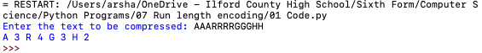

07.3